Nama : Alfian pandu

NIM :L200180027

Kelas : A

MODUL 7

“Managemen User dan Permission Direktori/File pada Linux” Praktikum1:

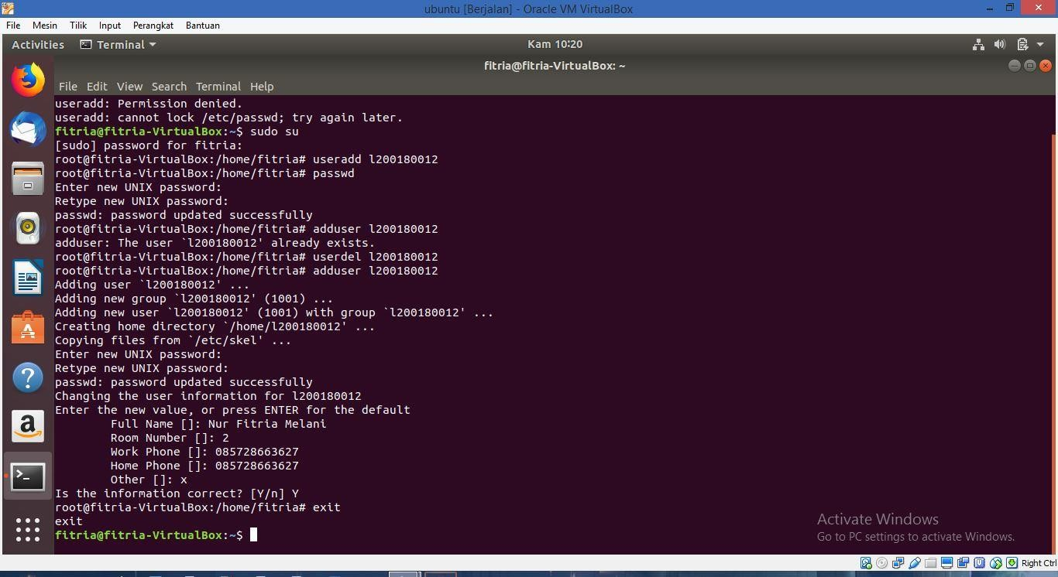

Praktikum2:

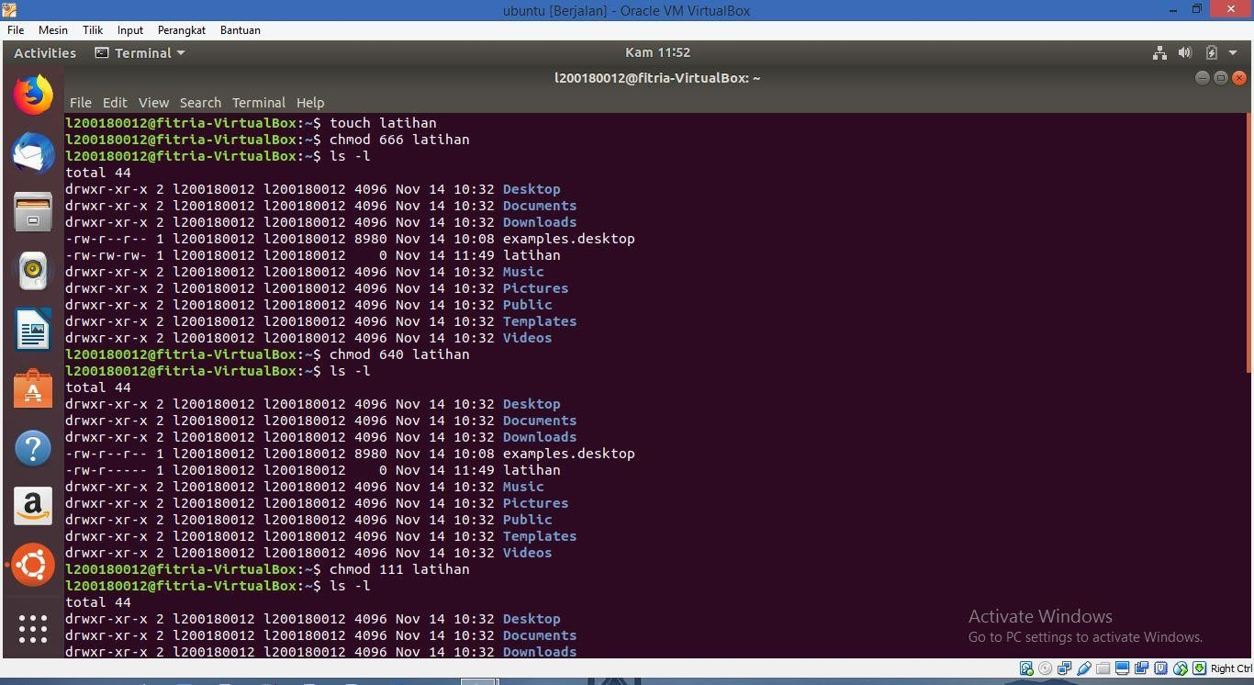

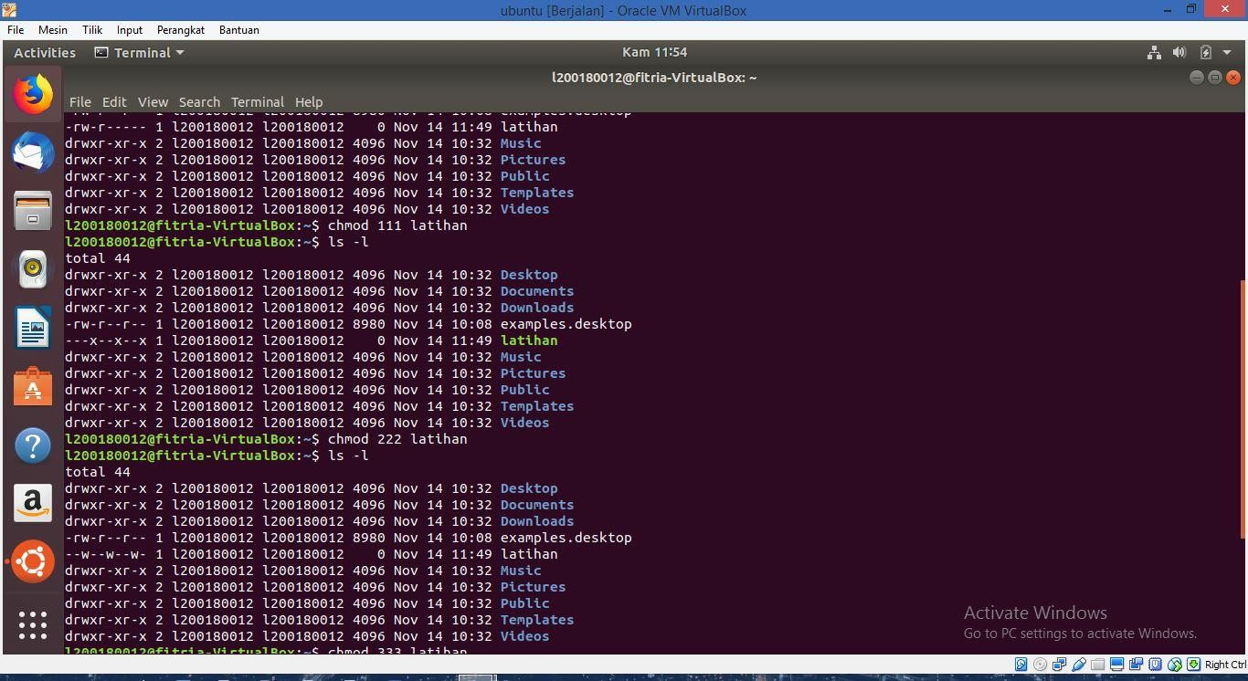

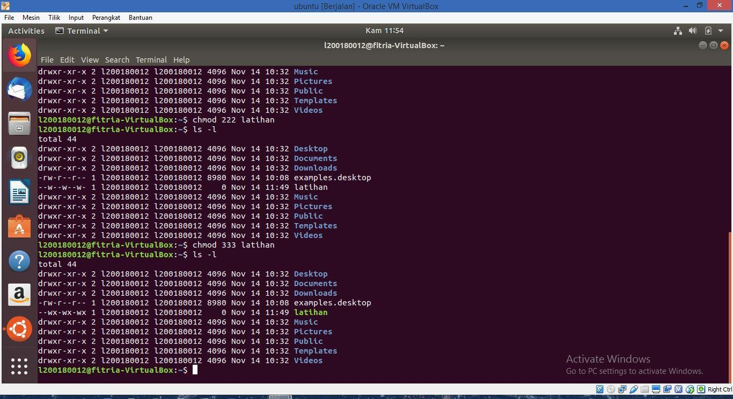

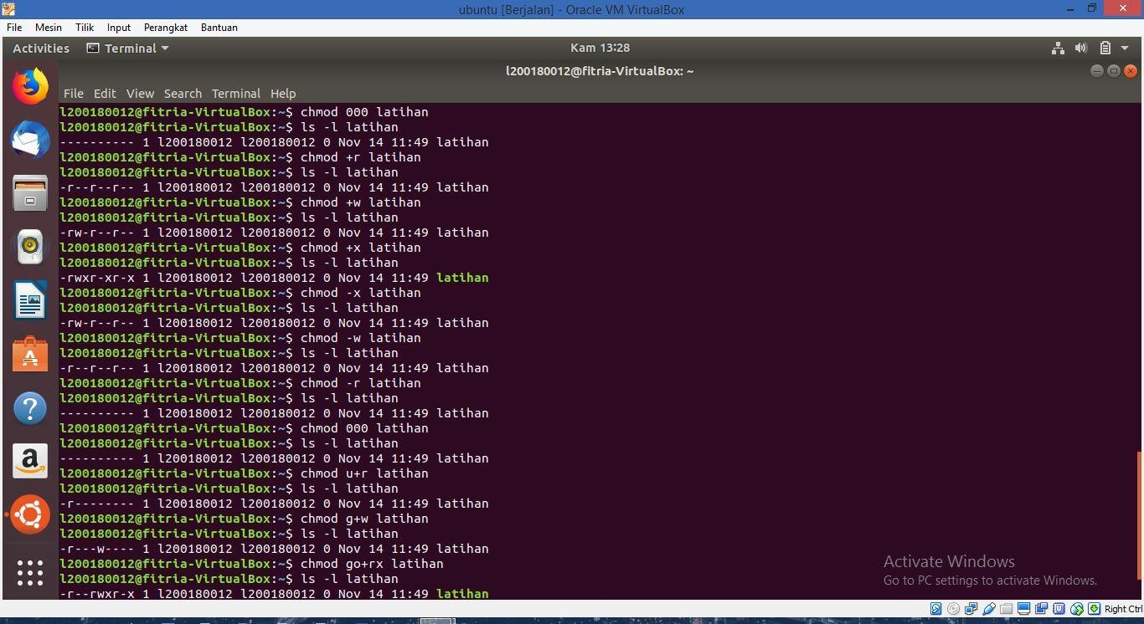

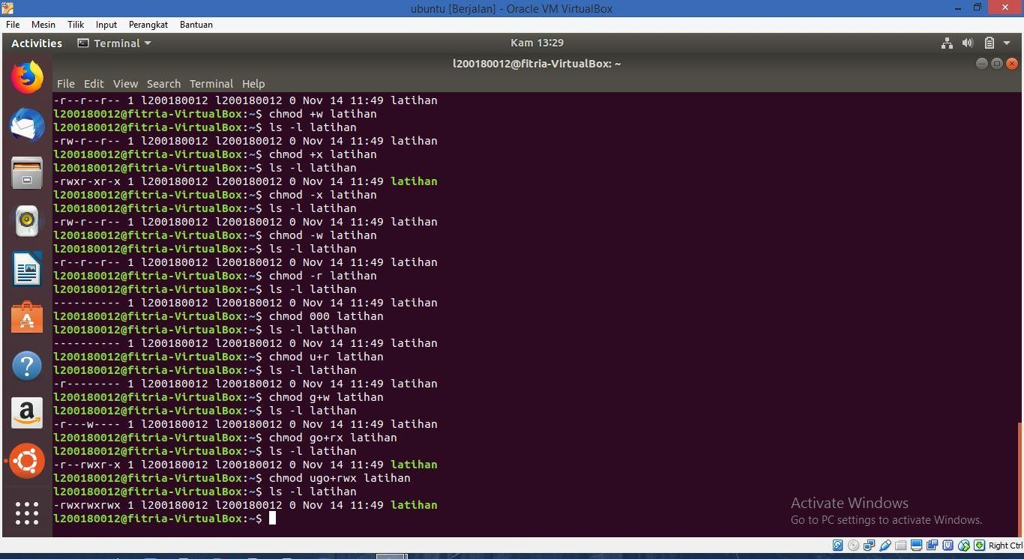

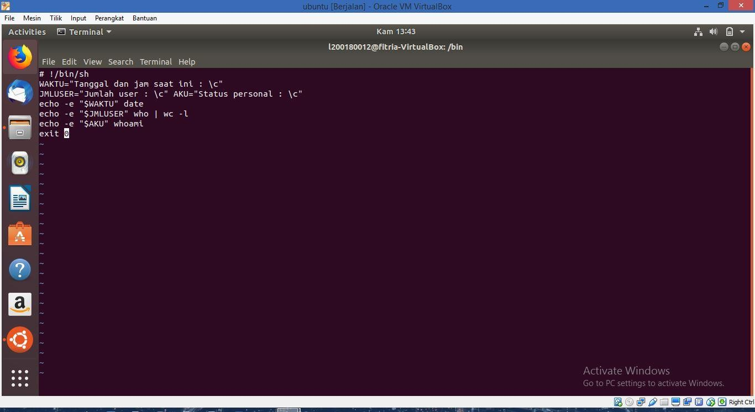

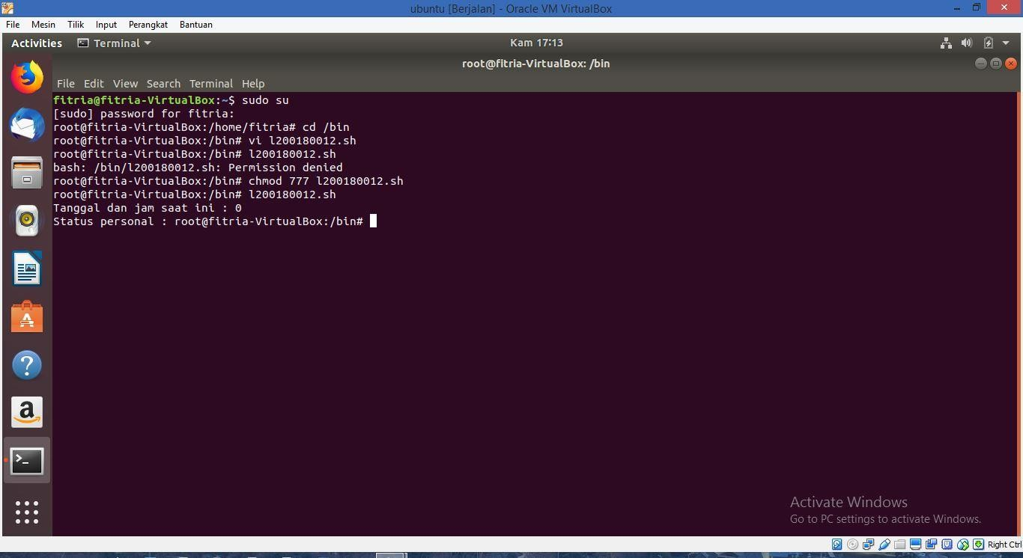

|  |  |
| --- | --- |
| 1. rw- rw- rw- | = 6 6 6 |
| 2. r-- r-- r-- | = 4 4 4 |
| 3. r-x r-x r-- | = 5 5 4 |
| 4. --x --x --x | = 1 1 1 |
| 5. rwx --- --- | = 7 0 0 |
| 6. r-x r-- r-- | = 5 4 4 |
| 7. rwx rwx --- | = 7 7 0 |
| 8. –w- -w- -w- | = 2 2 2 |
| 9. r-x rwx rwx | = 5 7 7 |
| 10. --x --x rwx | = 1 1 7 |